**Experiment - 2**

**Student Name: Vivek Kumar UID: 21BCS8129**

**Branch: BE-CSE(LEET) Section/Group: WM-20BCS-616/A**

**Semester: 5th Date of Performance: 20/08/2022**

**Subject Name: Project Based Learning in Java Lab Subject Code: 20CSP-317**

**1. Aim/Overview of the practical:**

Design and implement a simple inventory control system for a small video rental store.

**2. Task to be done/ Which logistics used:**

Write the program to design and implement a simple inventory control system for a small video rental store.

**3. Software Requirements (For programming-based labs):**

* JDK-8 or any
* Eclipse-IDE for Java

**4. Steps for experiment/practical/Code:**

import java.util.Scanner;

class Video {

public String title;

public boolean checked = true;

int avgrating;

public boolean checked() {

return checked;

}

public void rent() {

checked = false;

}

public void returned() {

checked = true;

System.out.println("Video is returned ");

}

public int getRating() {

if (avgrating > 0) {

return avgrating;

} else {

System.out.println("Rating is not available");

return 0;

}

}

}

class VideoStore extends Video {

Video v[] = new Video[10];

static int i = 0;

void addVideo(String title) {

v[i] = new Video();

this.title = title;

v[i].title = title;

i++;

System.out.println("Video Added Successfully");

}

void checkOut(String title) {

for (int k = 0; k < i; k++) {

if (v[k].title.equalsIgnoreCase(title)) {

if (v[k].checked()) {

v[k].rent();

System.out.println("Video is rented");

} else {

System.out.println("Sorry Video not available");

}

}

}

}

void returnVideo(String title) {

if (i == 0) {

System.out.println("You have no video to return");

}

for (int k = 0; k < i; k++) {

if (v[k].title.equalsIgnoreCase(title)) {

v[k].checked = true;

}

}

}

public void receiveRating() {

if (i == 0) {

System.out.println("No Video inInventory");

} else {

for (int k = 0; k < i; k++) {

System.out.println("Enter the integer rating for movie " + v[k].title);

Scanner ob = new Scanner(System.in);

v[k].avgrating = ob.nextInt();

}

}

}

public void listInventory() {

if (i == 0) {

System.out.println("No Video in Inventory");

} else {

for (int k = 0; k < i; k++) {

System.out.println(

k +

1 +

". " +

v[k].title +

" " +

"Rating " +

v[k].avgrating +

" Availability" +

v[k].checked()

);

}

}

}

}

public class VideoStoreLauncher {

public static void main(String[] args) {

VideoStore vs = new VideoStore();

int ch, uCh, aCh;

String title, choice;

do {

System.out.println("=========Menu=========");

System.out.println("1. Login as User");

System.out.println("2. Login as Admin");

System.out.println("Enter Your Choice");

Scanner s = new Scanner(System.in);

ch = s.nextInt();

do {

switch (ch) {

case 1:

System.out.println("1. List Inventory");

System.out.println("2. Rent Video");

System.out.println("3. Enter the rating of Video");

System.out.println("4. Return Video");

uCh = s.nextInt();

if (uCh == 1) {

vs.listInventory();

} else if (uCh == 2) {

vs.listInventory();

System.out.println("Enter the video Name you want");

title = s.next();

vs.checkOut(title);

} else if (uCh == 3) {

vs.receiveRating();

} else if (uCh == 4) {

vs.rent();

} else {

System.out.println("No such Option is available");

}

break;

case 2:

System.out.println("1. List Inventory");

System.out.println("2. Add Video");

aCh = s.nextInt();

if (aCh == 1) {

vs.listInventory();

}

if (aCh == 2) {

System.out.println("Enter the name of Video");

title = s.next();

vs.addVideo(title);

}

break;

default:

System.out.println("Sorry Wrong Choice");

}

System.out.println("Do you want to repeat yes/no");

choice = s.next();

} while (choice.equalsIgnoreCase("yes"));

System.out.println("Want to Return to main Menu yes/no");

choice = s.next();

} while (choice.equalsIgnoreCase("yes"));

}

}

**5. Observations/Discussions/ Complexity Analysis:**

Here we have created the VideoStoreLauncher, VideoStore and Video and I have Passed all the Parameters according to the Requirement given in the question.

**6. Result/Output/Writing Summary:**

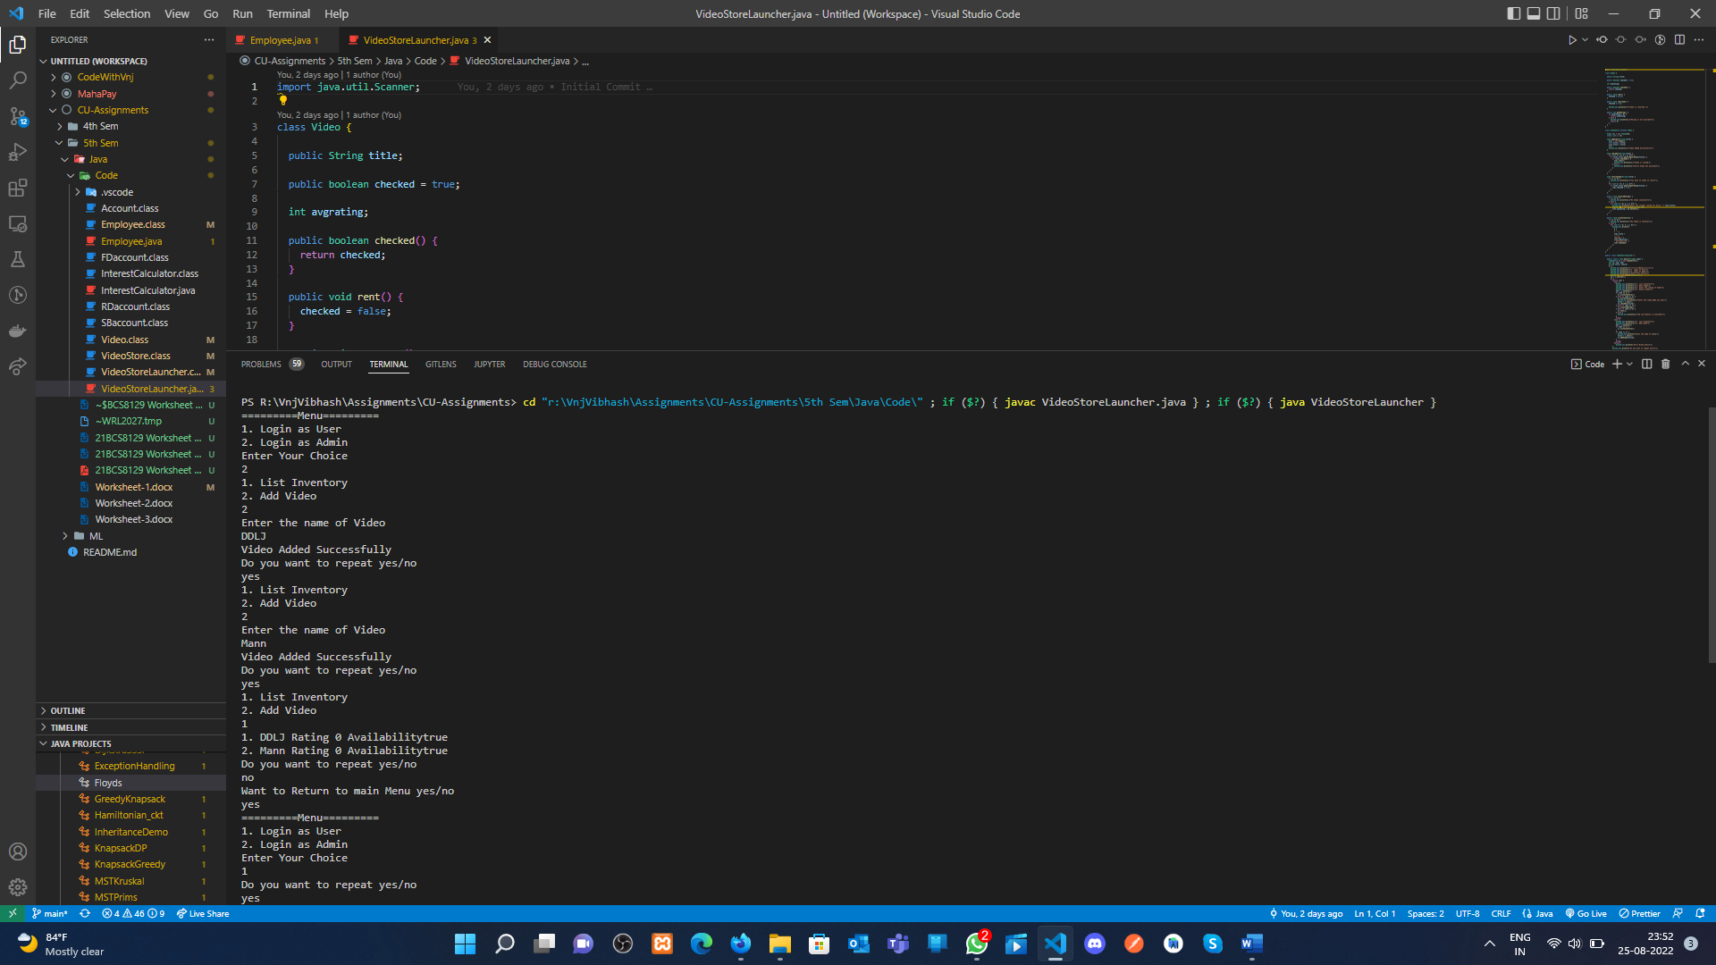

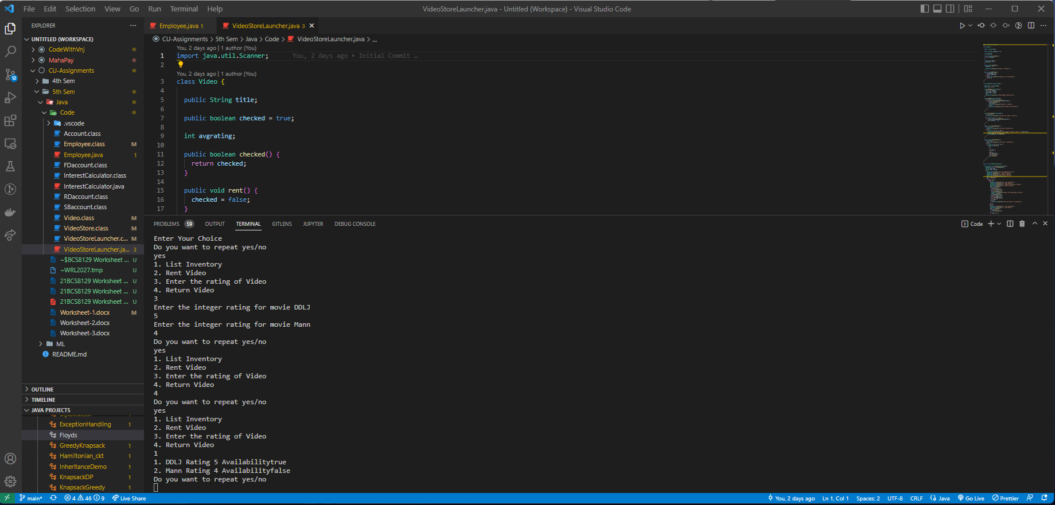

**Learning outcomes (What I have learnt):**

**1.** Learn How use the inheritance concept.

**2.** java classes and all the features.

**Evaluation Grid (To be created as per the SOP and Assessment guidelines by the faculty):**

|  |  |  |  |
| --- | --- | --- | --- |
| Sr. No. | Parameters | Marks Obtained | Maximum Marks |
| 1. |  |  |  |
| 2. |  |  |  |
| 3. |  |  |  |
|  |  |  |  |